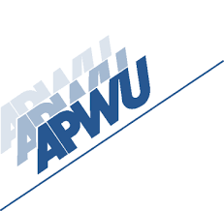



UNION MEETING

WESTERN NASSAU LOCAL 7115

Saturday March 21, 2026, AT 11: 00 AM

228 PETTIT AVE BELLMORE NY 11710

FOOD– REFRESHMENTS– RAFFLES

